**BUSINESS ANALYST**

**CAPSTONE PROJECT**

**E-FIXED DEPOSIT**

**Submitted to: Submitted by:**

**Simplilearn Rajachandra Shekar Reddy Naru**

**CONTENTS**

**1. INTRODUCTION.....................................................................................................................3**

**2. STAKEHOLDERS.....................................................................................................................4**

**3. AS-IS PROCESS FLOWCHART..................................................................................................5**

**4. FUTURE PROCESS FLOWCHART..............................................................................................6**

**5. SCOPE OF FD CREATION ........................................................................................................7**

**6. MAIN FEATURES TO BE DEVELOPED.......................................................................................7**

**7. IN SCOPE REQUIREMENTS......................................................................................................8**

**8. OUT OF SCOPE REQUIRMENTS...............................................................................................8**

**9. BUSINESS REQUIREMENTS.....................................................................................................9**

**10. WIRE FRAMES.....................................................................................................................10**

**11. USER STORIES & ACCEPTANCE CRITERIA..............................................................................11-12**

**12. TABLEAU DASHBOARD.......................................................................................................13**

**13. BAR GRAPHS......................................................................................................................14**

**14. VLOOKUPS..........................................................................................................................15**

1. **INTRODUCTION:**

One of the leading banks across the globe, is ABC Bank. It has a presence in 56 countries in the world.

ABC Bank currently has a manual option to create fixed deposits. The bank users go to the nearest ABC Bank branch and create a fixed deposit. ABC Bank has a future vision of being a 100% online bank and wants to do away with all its manual banking processes. They have identified the need to create e-fixed deposits.

ABC Bank currently wants to introduce this to their existing bank users with a plan of introducing this feature to non-ABC Bank users in future.

Advantages of opening an FD online

* **Easy and less time-consuming**: An online FD can eliminate the process of visiting the bank physically and makes the process of creating an FD an extremely easy and hassle-free process.
* **Easy payment:** Paying for the FD is extremely easy and can be done directly through net banking that makes the process of payment very convenient. All that is required is to transfer the money from the savings account to the respective FD account.
* **Easy renewal and closure:** Once an FD account is opened online, it is possible to renew and close the deposit online instantly. Therefore, it eliminates the need of going to the bank for any of these purposes.

1. **STAKEHOLDERS:**

|  |  |
| --- | --- |
| **ACTOR** | **What he can do on the Software Created** |
| **Customers** | * Customers can access the FD rates provided by the bank based on the age of the customer and FD amount without going to the bank physically. * They can open fixed deposit online by logging in with their savings/current/mobile banking. * They can transfer money into FD by using net banking |
| **Bank Managers** | * Bank managers can access the reports of FD’s opened online. * They can oversee the issues or complaints faced by customers while opening online FD. |
| **Bank Employees** | * Employees can process the renewing or cancelling requests of FD. * They can reply to the online queries and tickets raised by customers regarding FD. |
| **Regulatory Banking bodies** | * They can assess whether the online portal is adhering and following the norms and security guidelines dictated by the regulatory bodies. |

1. **AS-IS PROCESS FLOWCHART:**

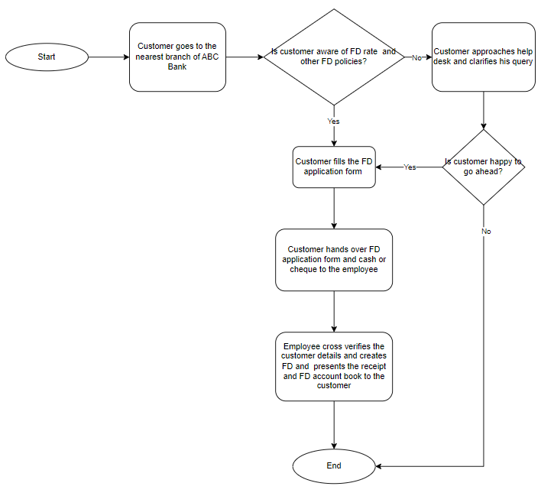

1. **FUTURE PROCESS FLOWCHART:**

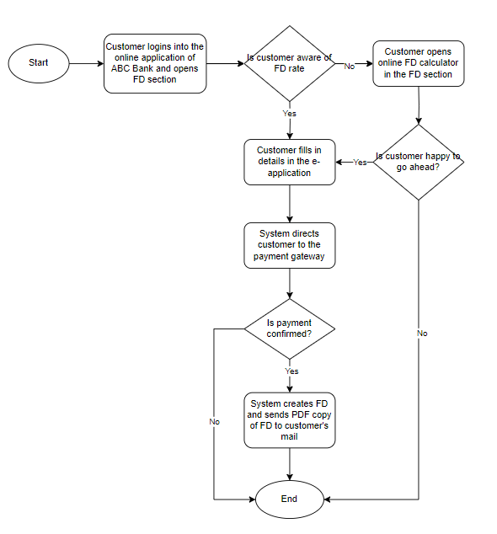

1. **SCOPE OF FD CREATION:**
   * As interest rate of FD is higher than any other rates provided by the banks, FD is better way of earning interest with security.
   * It is safer than any other investment which attracts lot of people to invest in FD’s.
   * One more reason for people choosing FD is with it, customers can avail 80-90% of the FD amount as loan.
   * It gives customers the freedom of selecting the tenure of FD which results in the constant demand of FD.
2. **MAIN FEATURES TO BE DEVELOPED:**
   * IT team must create a dedicated FD page in the existing bank application which can be accessed through web and mobile.
   * They also need to create and add FD calculator which helps customers and employees in calculating the maturity amount to be received by the end of the policy tenure.
   * They should also add an option to add multiple customer details which can be used while creating joint accounts.
   * The team should build a payment gateway which should be able to deduct money from debit, credit cards and bank accounts.
   * The system should also be able to send an automatic PDF copy of FD document in the case of successful creation of FD.
   * The FD page should be able to generate certain types of reports to the bank.
3. **IN SCOPE REQUIREMENTS:**
   * FD page should have renewal and closure options which should be given access to customers.
   * FD calculator should calculate the maturity amount based on the age and amount of money that customer wants to invest in FD.
   * FD page should have an option to debit money from any type of ABC Bank account of the customer.
   * It also should have an option to add nominee details in the FD account.
   * In case of minor customer/nominee, the system should ask for guardian details and age.
4. **OUT OF SCOPE REQUIREMENTS:**
   * Customers should either have mobile/savings/online banking to create an FD account.
   * Customers can’t create FD if they choose less than 1 week period and any period more than 10 years.
   * e-FD account is only limited to the customers of ABC Bank.
5. **BUSINESS REQUIREMENTS:**
   1. **FUNCTIONAL REQUIREMENTS:**
   * FD page should accept all types of accounts of ABC Bank i.e., mobile, savings and online bank to create a FD account.
   * It should display the FD calculator for the customer to use.
   * It should allow the customer to use any of his ABC bank accounts to debit money for the FD.
   * The system should allow customer to renew the FD
   * It also should let customer to transfer the maturity amount to current or savings account.
   * There should be option to create joint account.
   * When the user/nominee is minor it should take the guardian details.
   * The system should take nominee details for the FD account.
   * It should send the PDF copy of FD.
   * It should be able to generate reports on FD to the bank.
   1. **NON-FUNCTIONAL REQUIREMENTS:**
   * ABC Bank want to give easy and hassle-free experience to its customers in opening online FD.
   * The Bank also wants to make payments and renewals quick and online in the case of FD
6. **WIREFRAMES:**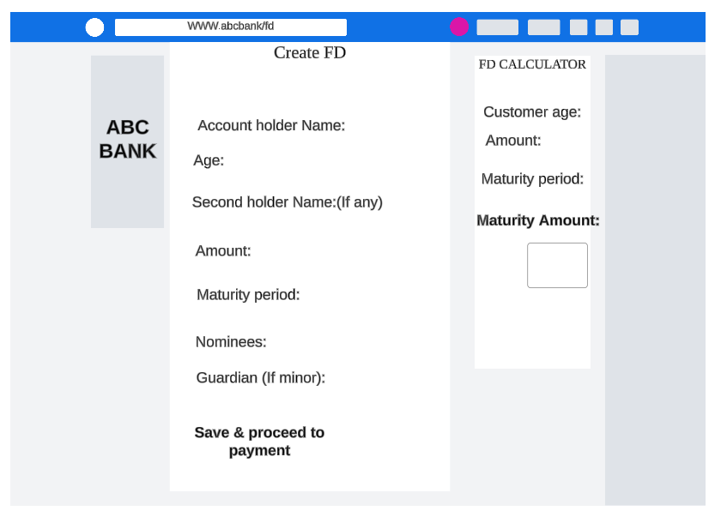

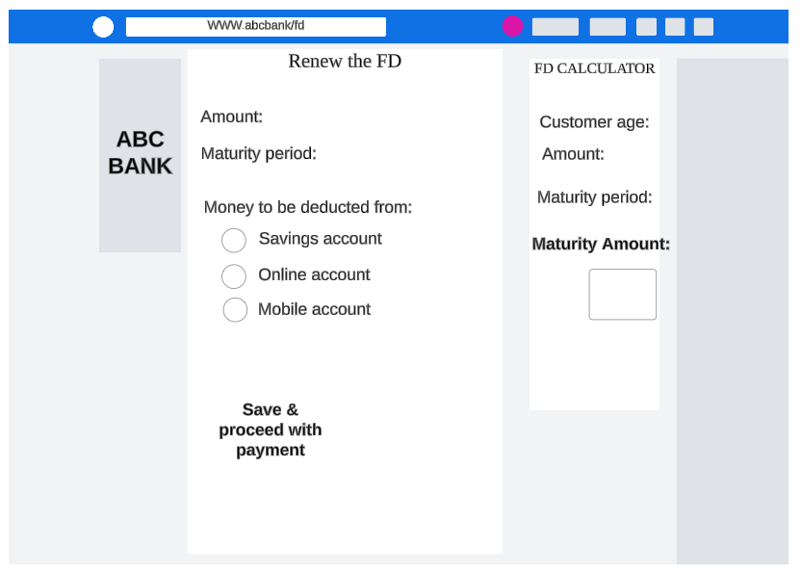

**11. USER STORIES & ACCEPTANCE CRITERIA:**

|  |  |
| --- | --- |
| **Problem Statement 1** | |
| As a customer  I want to be able to use FD calculator in the FD page itself  So that I get to know the FD rate for my age | |
|  | **Acceptance criteria** |
| **1** | Given that the customer is trying to calculate FD rate  When the customer clicks on the FD calculator  Then the user should be able to enter the age and amount of money |
| **2** | Given that the customer is trying to calculate FD rate  And the customer clicks on the FD calculator  When the customer enters only one i.e., either age or money  Then the customer should not be able to get the FD rate |

|  |  |
| --- | --- |
| **Problem Statement 2** | |
| As a customer  I want to add second account holder details in online FD form  So that I can open joint FD account | |
|  | **Acceptance criteria** | |
| **1** | Given that the customer is trying to open joint account  When the customer clicks on the second account holder  Then the user should be able to enter the name of the other holder | |
| **2** | Given that the customer is trying to open joint account  And the customer clicks on the second account holder  When the customer enters the second account holder name and age any number less than 18  Then the system should ask the customer to fill in the guardian details | |

|  |
| --- |
| **Problem Statement 3** |
| As a customer  I want to be able to receive the PDF copy of FD to my mail after creating the FD account  So that I can have the FD copy saved in my device  (mobile/pc) to go through it whenever I want |
| **Acceptance criteria** | |
| Given that the customer is trying to save the FD copy in the device  When the customer creates FD account after the payment  Then the user should be able to receive the FD copy to the mail | |

|  |  |  |
| --- | --- | --- |
| **Problem Statement 4** | | |
| As a bank manager  I want to be able to generate reports on FD accounts  So that I can be able to look at the number and type of accounts created in a period | | |
|  | **Acceptance criteria** |
| **1** | Given that the bank manager is trying to look at the FD reports  When the manager clicks on generate the FD reports after selecting the period  Then the manager should be able to view and download the FD related reports |
| **2** | Given that the bank manager is trying to look at the FD reports  And the manager clicks on generate the FD report  When the manager does not select the date while generating report  Then the manager should be able to view the FD reports |

**12. TABLEAU DASHBOARD:**

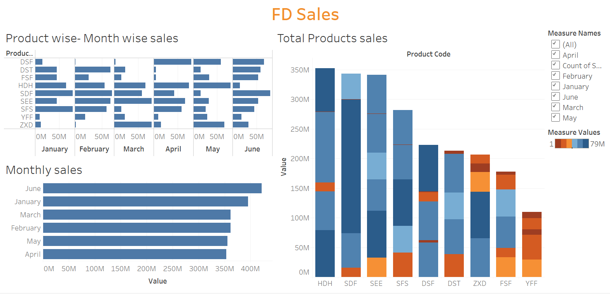

Profile link:<https://public.tableau.com/app/profile/rajachandra.naru>

**13. BAR GRAPHS:**

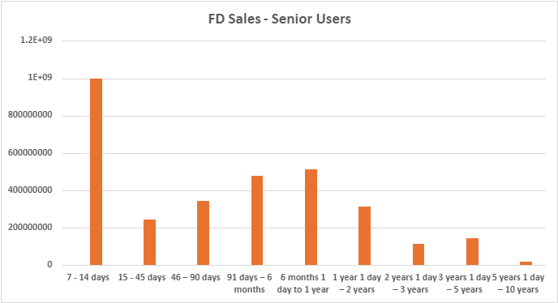

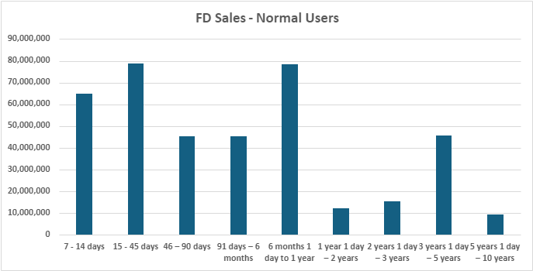

**14. LOOKUPS:**

A. Using VLOOKUP for product code HDH, find the rate for senior citizens for amounts less than 2 crores

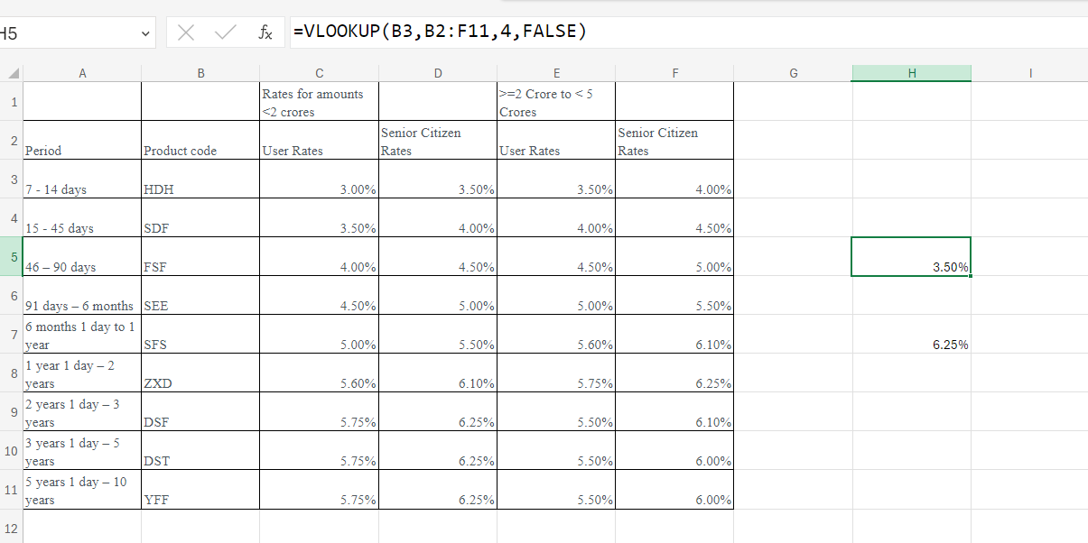

B. Using VLOOKUP for product code YFF, find the rate for senior citizens for amounts less than 2 crores

